ServiceNow Incident Management Project Documentation

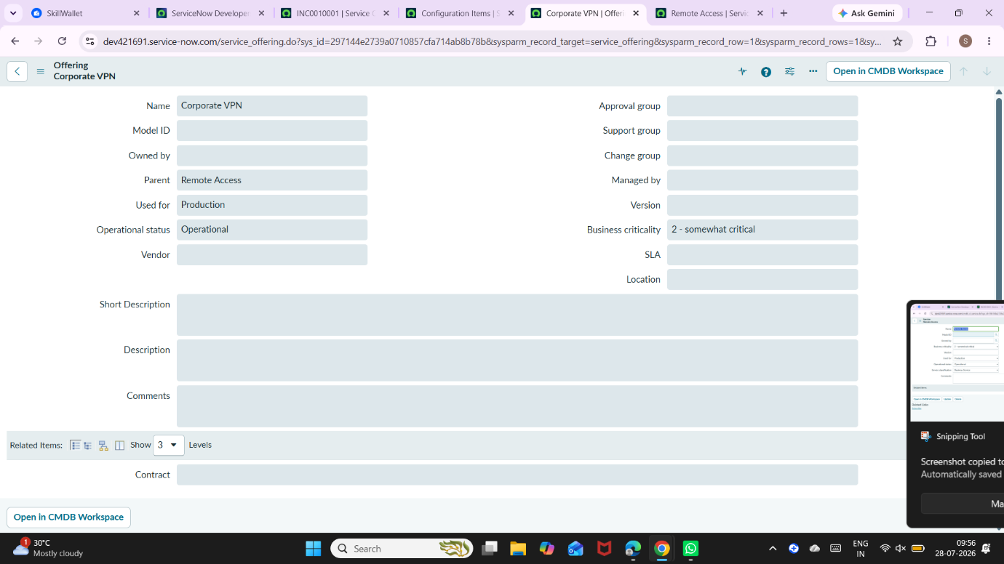
Shows creation of a new service “Remote Access” with operational status set to Operational in ServiceNow.

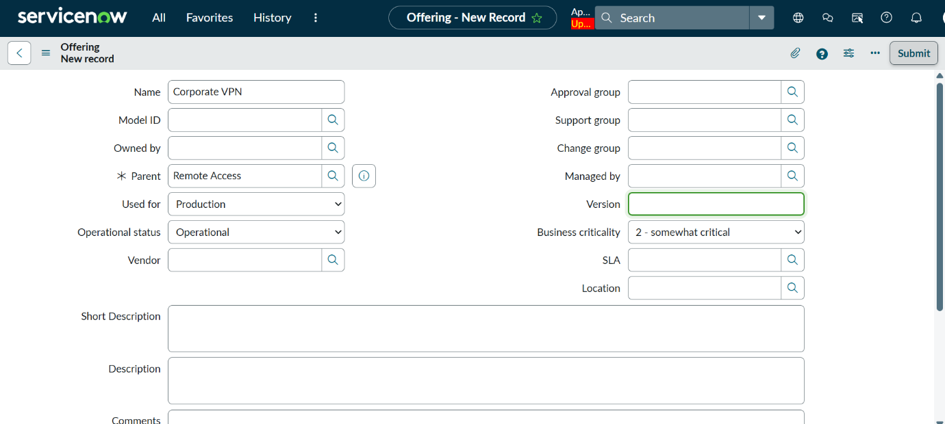

Shows creation of “Corporate VPN” service offering linked to Remote Access with operational status set to Operational.

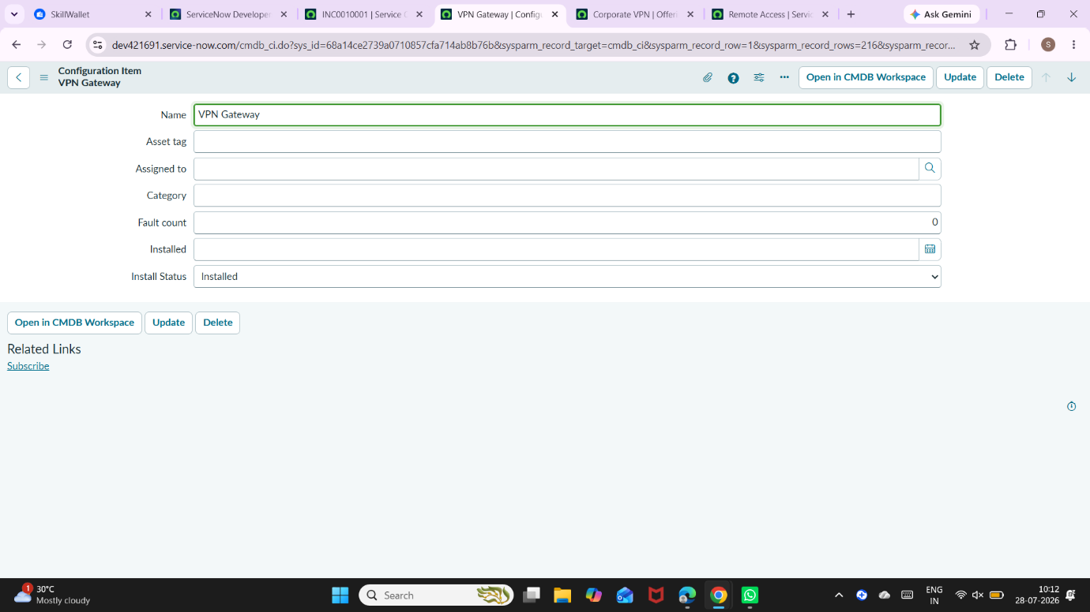
Shows creation of “VPN Gateway” configuration item in CMDB.

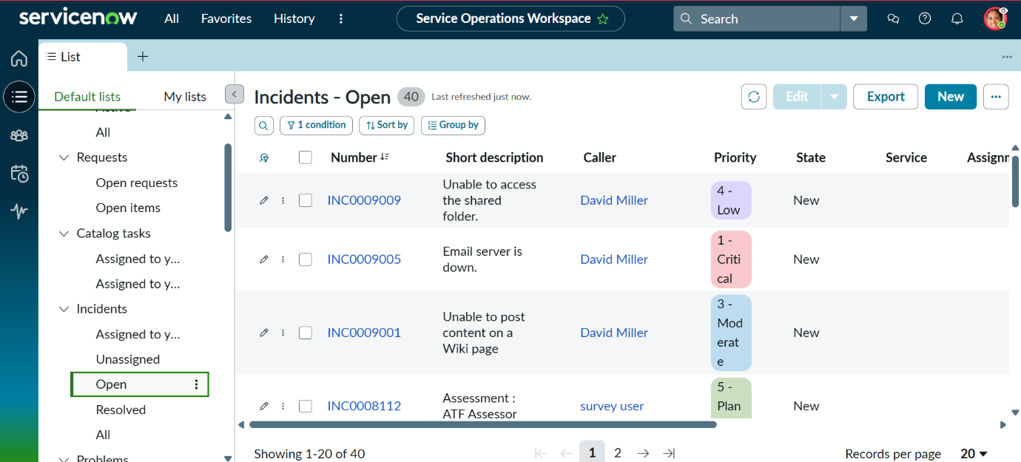
Shows impersonation of Beth Anglin and navigation to open incidents with New button selected
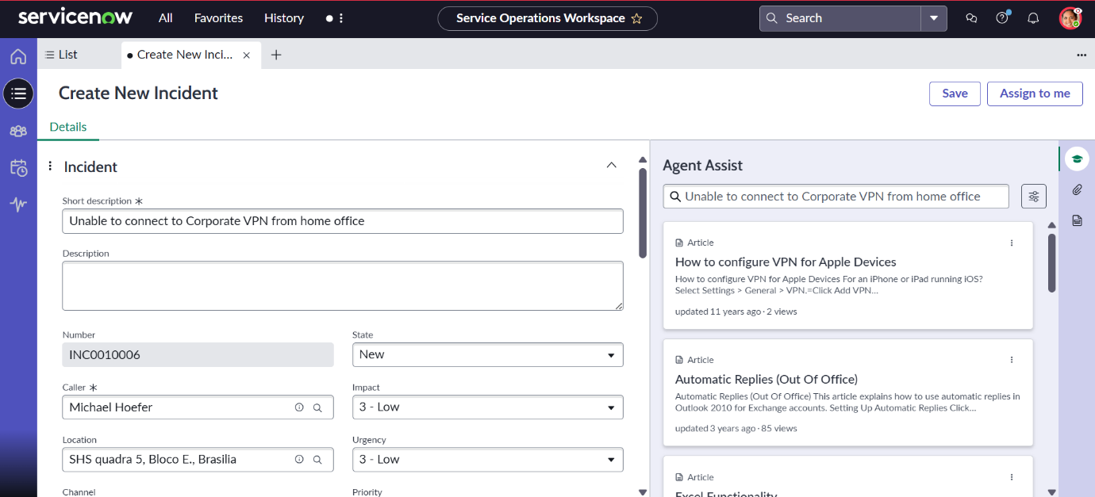
Shows incident details filled with caller Michael Hoefer and VPN connectivity issue description.
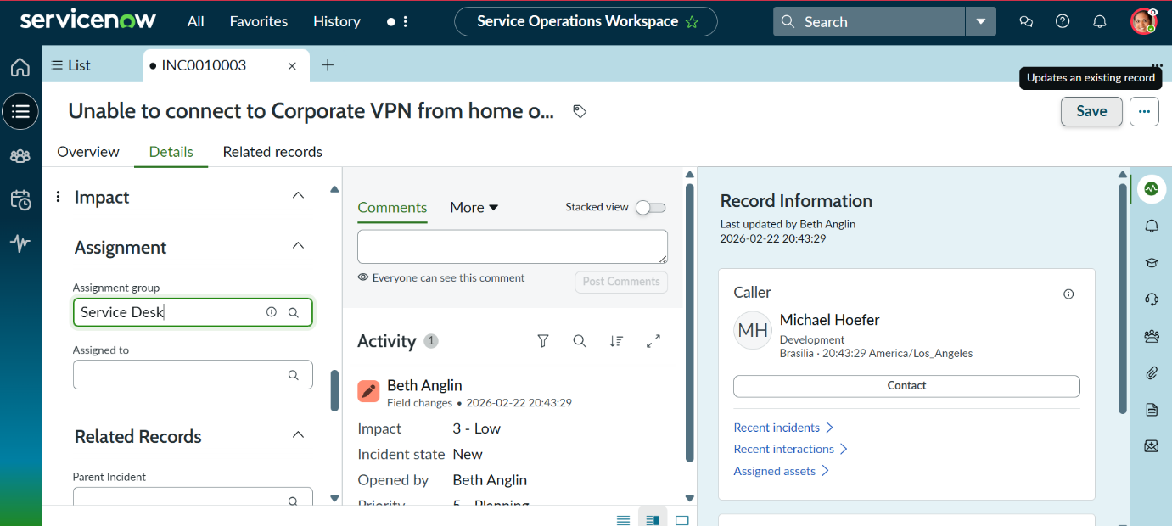
Go to the Details tab in ServiceNow and set Assignment Group as Service Desk. Click Save to update the incident.
- 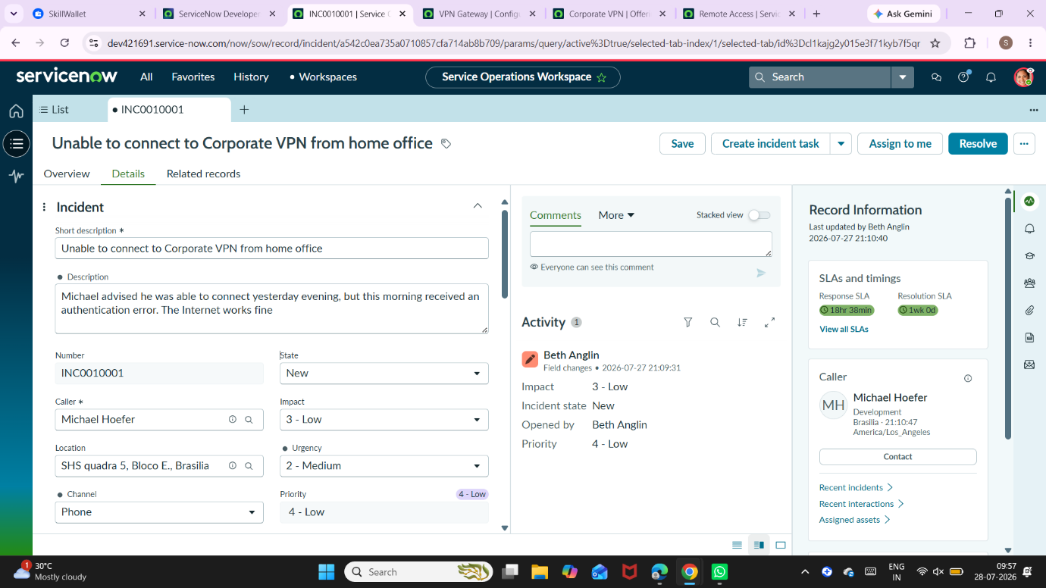
Updating incident information by adding description, setting category as Network → VPN, urgency as Medium, and linking service, service offering, and configuration item in ServiceNow. The incident is then assigned and saved

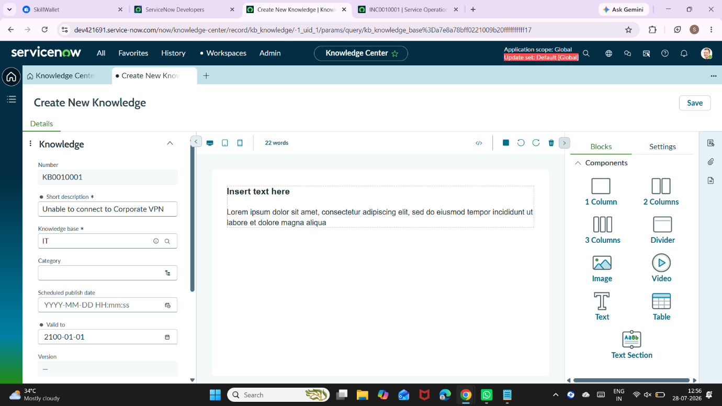
Using Agent Assist in ServiceNow to view relevant knowledge articles based on the incident description, mark an article as helpful, and attach it to the incident. Then return to verify the article is linked.

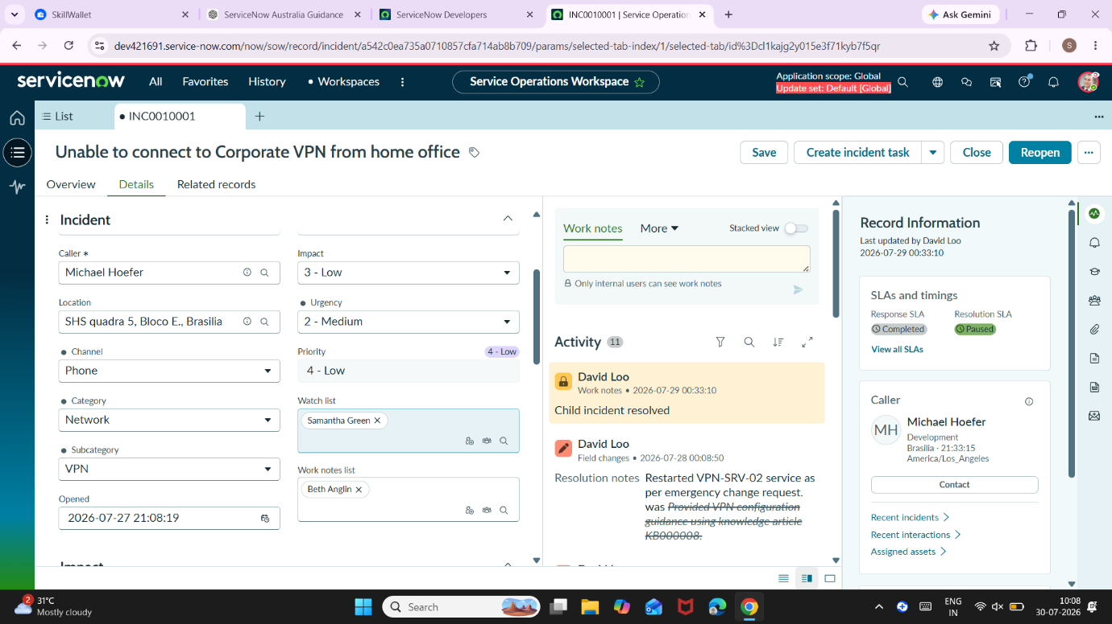
In Details tab:
Add Samantha Green to the Watch list.
Add Beth Anglin to the Work notes list.

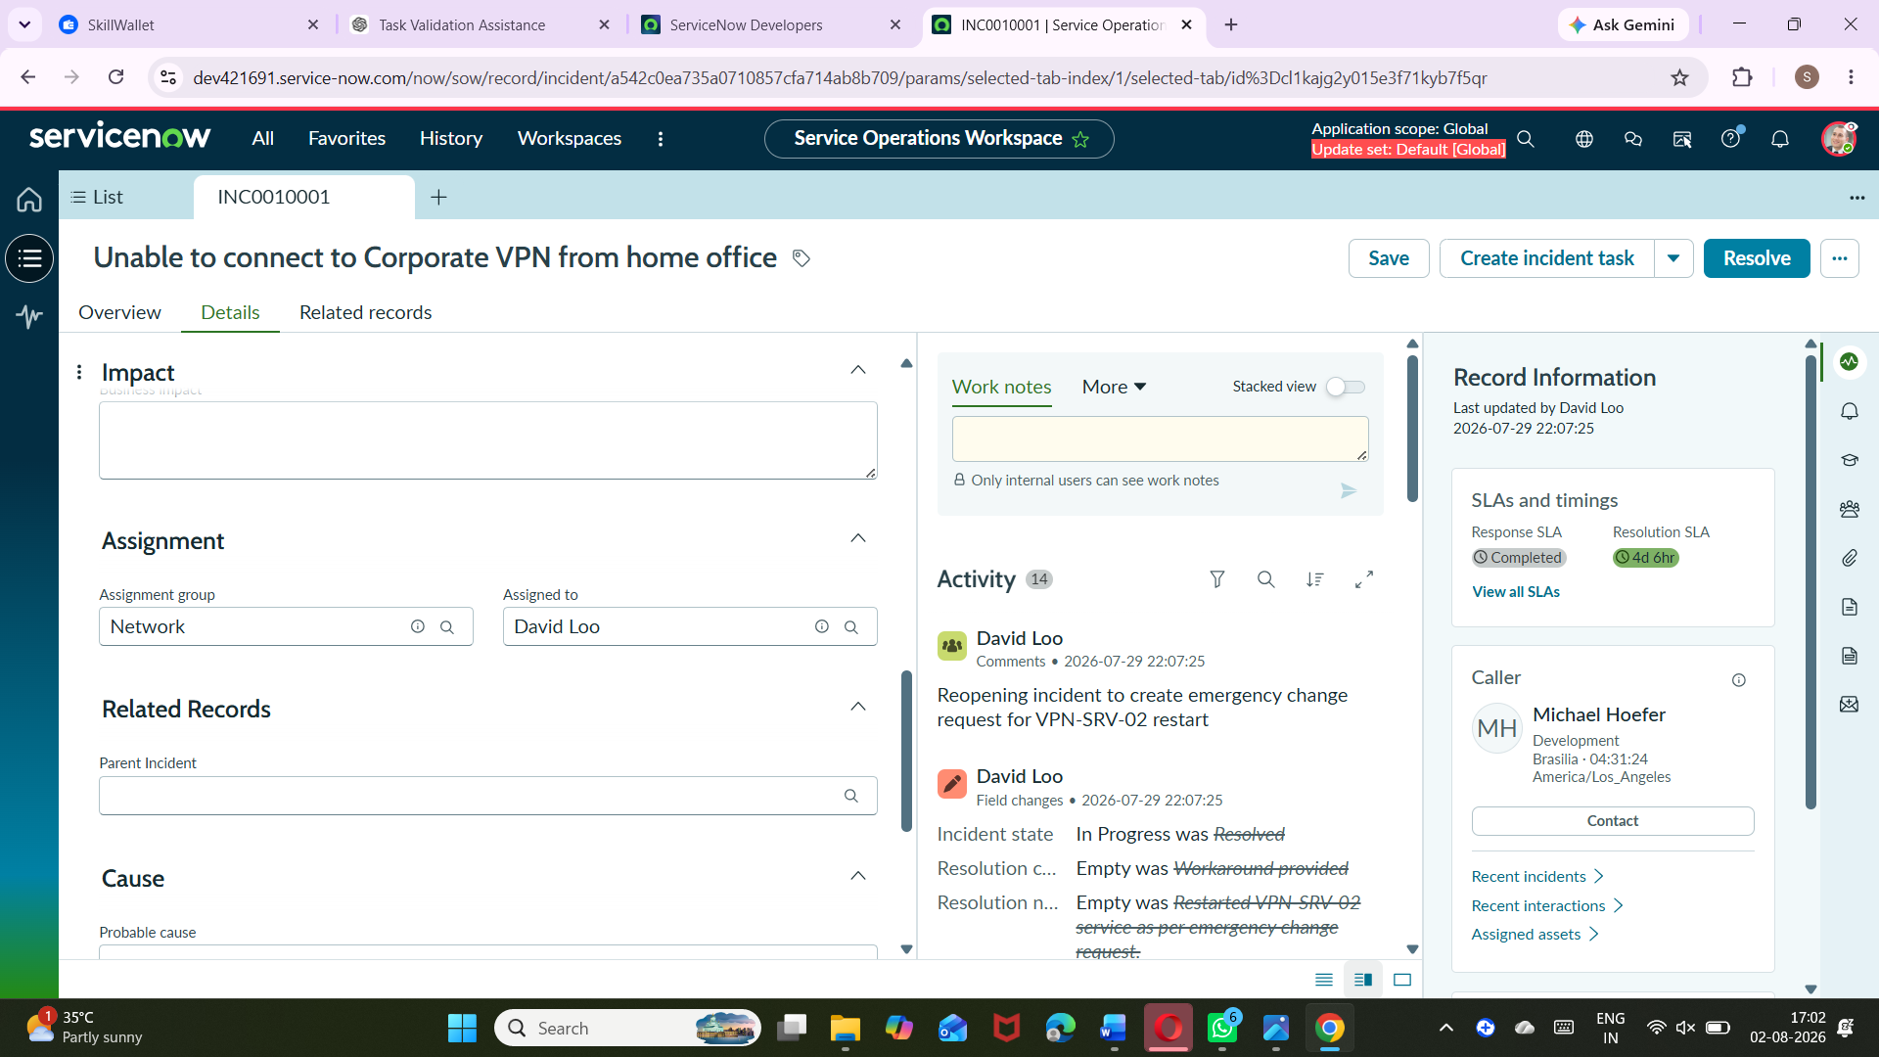
Update Assignment group to: Network
Verify Assigned to field clears automatically.
Click Save.
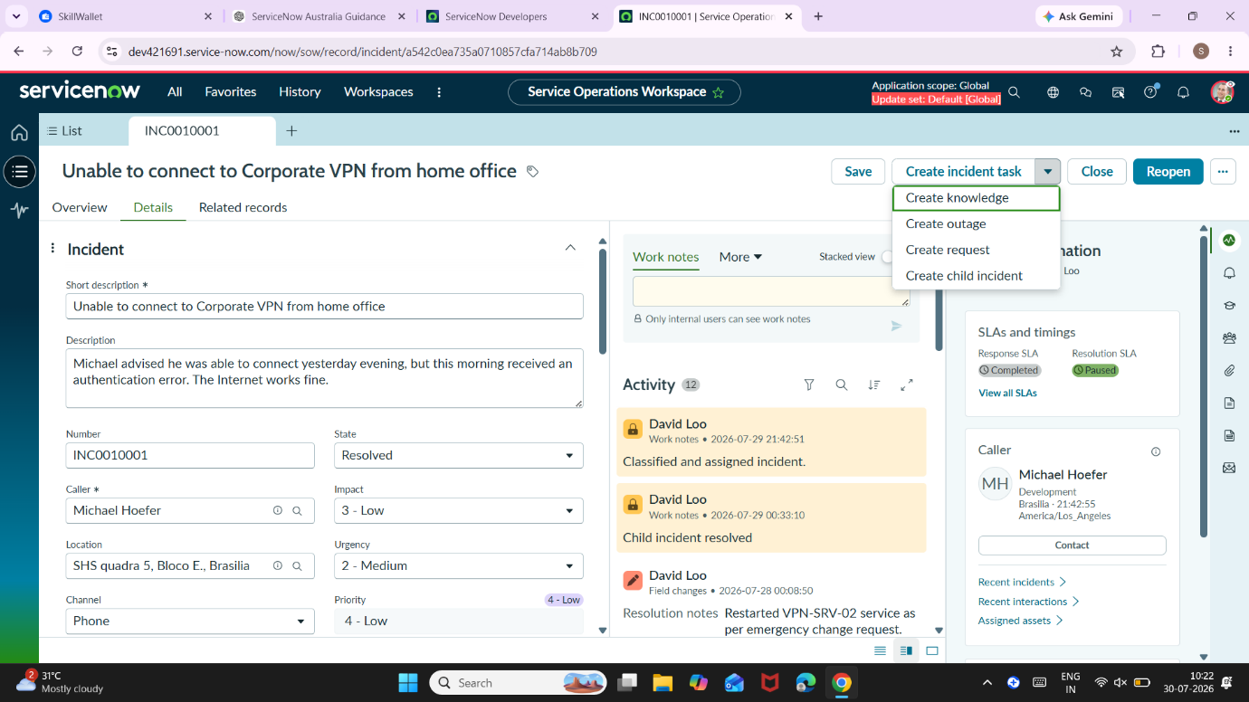

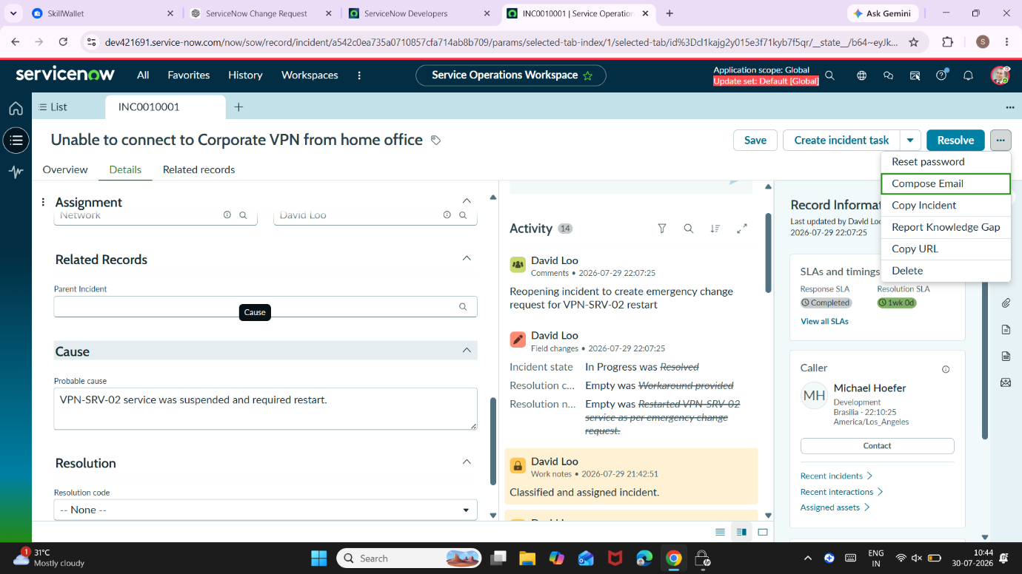
Update CI to VPN-SRV-02 in ServiceNow, create an Emergency change request, and update required fields like category, impact, description, and assignment to David Loo, then save.
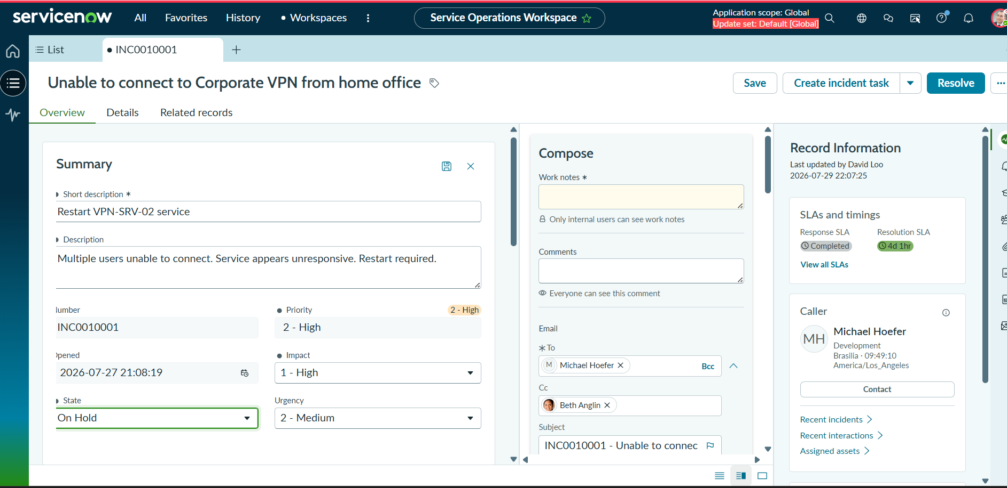Updated the Configuration Item from VPN Gateway to VPN-SRV-02 and saved the incident. Created an Emergency Change Request by updating category as Network, impact as High, and assigning it to David Loo with required details.
Linked the change request to the incident and updated the incident state to On Hold with reason Awaiting Change, then saved the record.

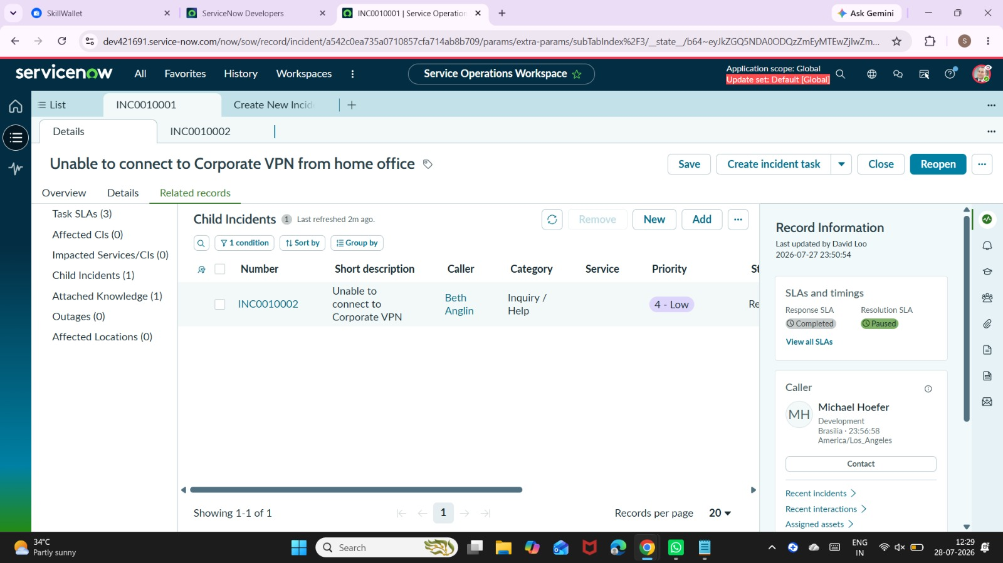

From Related Records → Child Incidents in ServiceNow, create a new child incident with VPN issue details and save. Note the incident number and return to the parent incident.
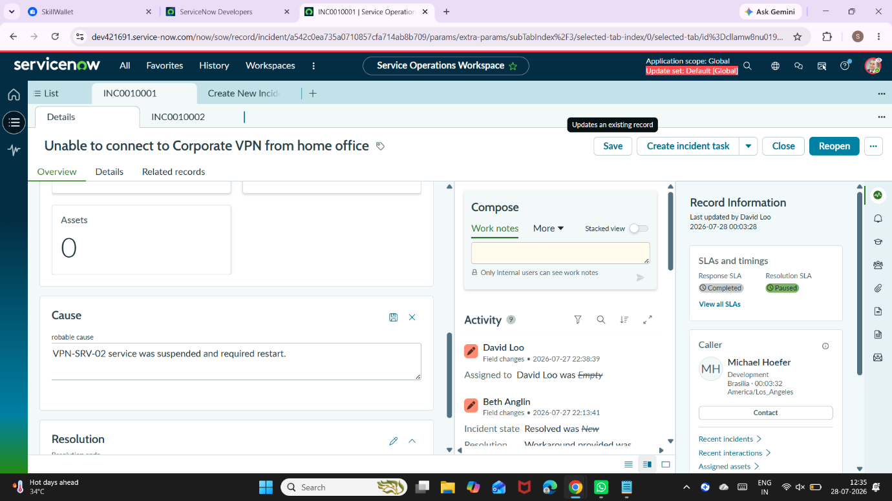
In the Overview tab of ServiceNow, add the probable cause stating VPN-SRV-02 service was suspended and required restart, then save.

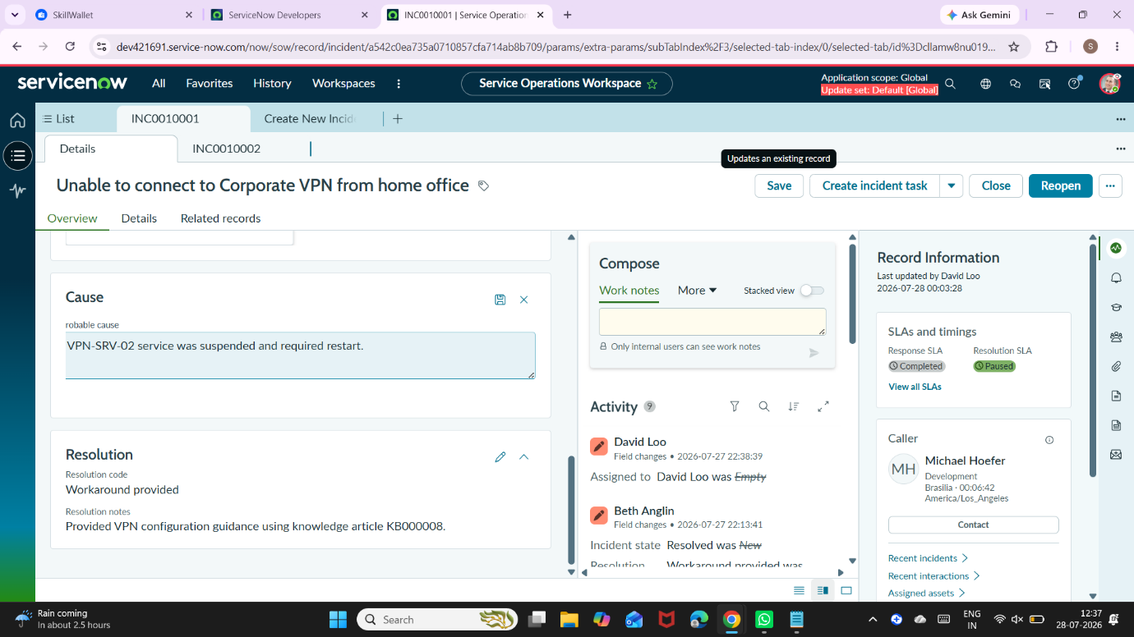
Add resolution details in ServiceNow by setting resolution code as Workaround provided and updating notes about restarting VPN-SRV-02 service, then save. Click Resolve and confirm to complete the incident.


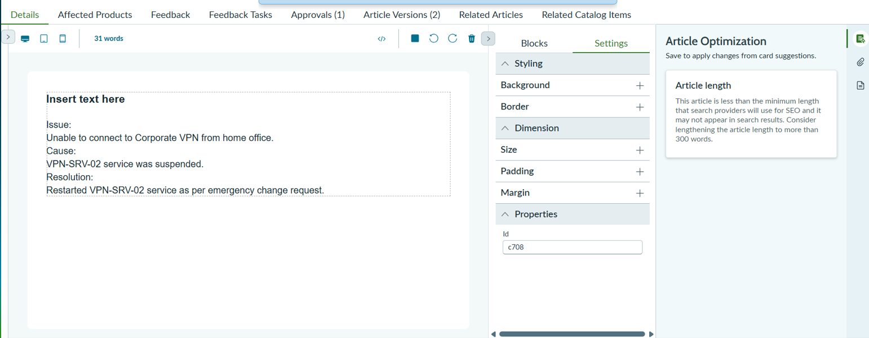Create a knowledge article from the incident in ServiceNow and verify fields like short description, issue, resolution, and source task are auto-filled. Publish the article to make it available.
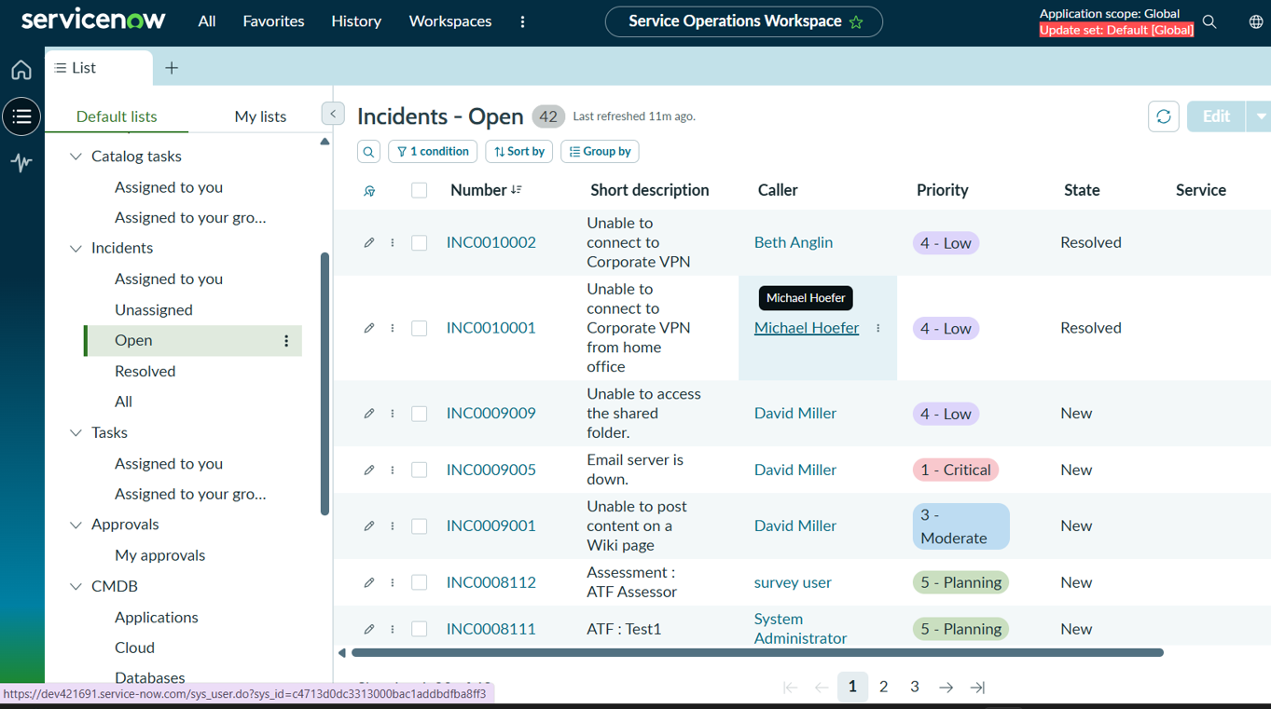

Verify in ServiceNow that parent and child incidents are resolved, activity shows resolution from parent, change request is linked, knowledge article is created, and SLA tracking is visible

